**Task 1:**

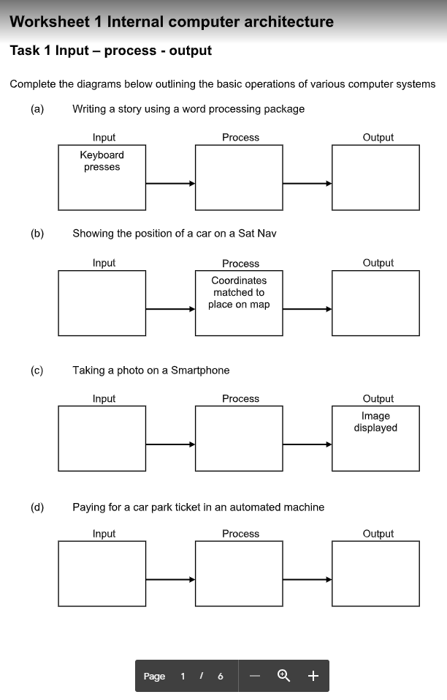

Key specific characters encoded into computer

Letters typed are shown on display

Coordinates of the car are worked out

Location displayed on the satnav

Button pressed to take picture

Camera shutter opens and takes an image at that time

Car parking ticket and payment inserted into machine

Ticket code is read and its data is changed to say it is payed

Ticket is displayed as payed

**Task 2:**

1. Four internal computer components are: CPU (central processing unit), input devices, output devices, and storage devices.
2. Three external components are: the monitor, mouse, and keyboard.

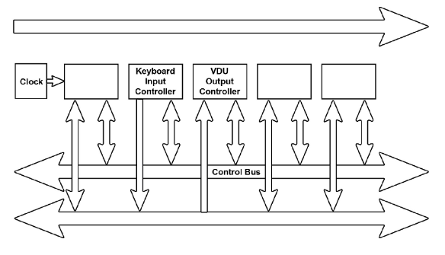**Task 3:**

v

A)

Address Bus

Data Bus

Memory

Disk I/O Controller

Processor

B) A parallel bus is able to transfer data in both directions. The control bus and the data bus are both parallel. The control bus sends signals between the Input/output controller and the processor, and also between the processor and the memory. The data bus sends data between the CPU and the components. However, a serial bus only sends data in one direction. The address bus is an example of this. It sends memory addresses from the processor to CPU components.

C) In the traditional von Neumann computer, the control bus is the only parallel bus. It is used to transfers data between the processor and the memory.

D)

E)

F) The data bus sends data between the CPU and the components in both directions. Its width is a factor in overall system performance as if the data being sent is larger than the capacity of the bus, then the processor must access the main memory multiple times, making it take longer.

G)

H) If the address space of a computer system is 220 this means that it has 1048576 bits available to carry addresses across the address bus to the processor.

I) If the address bus has 16 lines, then it has 2^16 bits available.

**Task 4:**

1. The Harvard architecture resolves this issue by separating the data and the program into different sections and using different buses, so that it can both write data and read an instruction at the same time.
2. An advantage of this is that the program instructions are now no longer competing for the same bus, so the computer can run faster. This type of architecture is commonly used in more specialist computers, rather than general use.